SAC Extended History Loss Run
The extended history (XHIST) loss run, in appearance looks no different from our regular loss run design, it is just with the history going back to a particular date we choose. The cover page of our existing loss run specifies that the data within our standard loss run is limited to “…all open claims; as well as closed claims limited to the current and prior six policy years.”
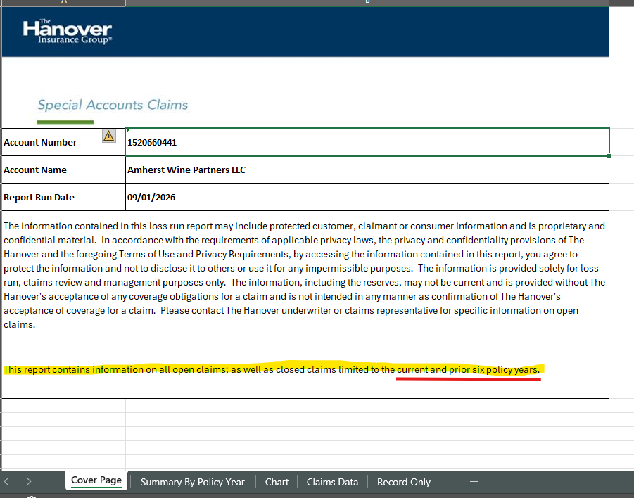

I think the best way to illustrate how our extended history loss run worked in the OBIEE system is to simply show the dashboard where we pulled these reports from. Instead of the six years of history we currently get with a loss run, we want to be able to select a particular cut-off date in how far back will be pulling in closed claims into the report.
